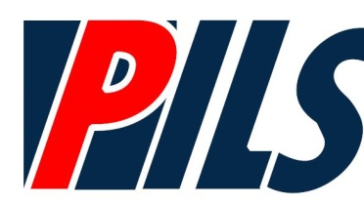
September is National Preparedness Month
We can all take action to prepare
Thursday, September 28, 2017
1pm – 3:30pm
Disaster Preparedness 1pm-2pm
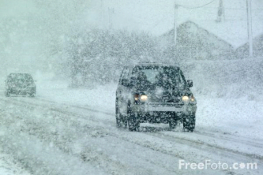
When unexpected events occur such as hurricanes, northeasters or heavy snowfalls we sometimes wait for disaster to strike; and sometimes, we have no warning. In all situations basic knowledge and preparation is the key to survival and recovery. We will talk about what to have ready to go, how to plan with your family, about pets, as well as how you can prepare everything from documents to home protection.
Special presentation by WILC staff on NY Connects, No Wrong Door
Staying Strong and Resilient 2:20pm- 3:20pm
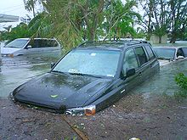
Are you facing challenges, had a change or loss in your life, or are a caregiver? How do you handle challenges, problems and hardships in your life? Learn strategies for staying strong and resilient, maintaining a positive outlook, and reducing stress.

Snacks will be served
Workshops are Free but You Must Register

Register by emailing lkelly@putnamils.org or call 845.228.7457 extension 1110
or through our website calendar on www.wilc.org

Putnam Independent Living Services
1441 Route 22, Suite 204, Brewster NY 10590

If you need any special accommodations please let us know ASAP.

